

**Koneru Lakshmaiah Education Foundation (Deemed to be University)**

**Course Code:22EC2208R Course Name: Digital Communication**

**A Project Based Lab Report On**

**BIT ERROR ESTIMATOR**

**SUBMITTED BY:**

ID NUMBER: NAME:

2200040150 M. ABHISHEK

2200040192 CH. LEELA RAJA KUMAR

2200040231 V. ROHITH

**UNDER THE GUIDANCE OF**

**Dr. RAVI KUMAR MOKKAPATI**

**Associate Professor**

Green fields, Vaddeswaram – 522 302 Guntur Dist., AP, India



**K L E F**

**DEPARTMENT OF ELECTRONICS AND COMMUNICATION ENGINEERING**

**(DST-FIST Sponsored Department)**

**DECLARATION**

The Project Report entitled **“BIT ERROR ESTIMATOR”** is a record of bonafide work of **2200040150, M.ABHISHEK, 2200040192, CH.LEELARAJAKUMAR, 2200040231, V.ROHITH,** submitted in partial fulfillment for the award of B.Tech in Electronics and Communication Engineering to the K L University. The results embodied in this report have not been copied from any other departments/University/Institute.



**K L E F**

**DEPARTMENT OF ELECTRONICS AND COMMUNICATION ENGINEERING**

**(DST-FIST Sponsored Department)**

**CERTIFICATE**

This is to certify that the Project Report entitled “**BIT ERROR ESTIMATOR**” is being submitted **2200040150, M.ABHISHEK, 2200040192, CH.LEELARAJAKUMAR, 2200040231, V.ROHITH,** submitted in partial fulfillment for the award of B.Tech in Electronics and Communication Engineering to the K L University is a record of bonafide work carried out under our guidance and supervision.

The results embodied in this report have not been copied from any other departments/ University/Institute.

Signature of Supervisor

Signature of the HOD Signature of the External Examiner

**ACKNOWLEDGMENT**

It is great pleasure for me to express my gratitude to our honourable President **Sri. Koneru Satyanarayana**, for giving the opportunity and platform with facilities in accomplishing the project report.

I express the sincere gratitude to our Vice Chancellor, **Dr G P S Varma** for his administration towards our academic growth.

I express the sincere gratitude to our Pro VC, **Dr N Venkatram** for his administration towards our academic growth.

I record it as my privilege to deeply thank our principal, **Dr. T. K. Ramakrishna Rao** for providing us the efficient faculty and facilities to make our ideas into reality.

I express sincere gratitude to our pioneer **Dr. Suman Maloji** HOD-ECE for his leadership and constant motivation provided in successful completion of our academic semester.

I express my sincere thanks to our project mentors **Dr Ravi Kumar Mokkapati** for their novel association of ideas, encouragement, appreciation and intellectual zeal which motivated us to venture this project successfully.

Finally, it is pleased to acknowledge the indebtedness to all those who devoted themselves directly or indirectly to make this project report success.

**ABSTRACT**

In modern communication systems, ensuring the accuracy and reliability of transmitted data is paramount. The Bit Error Estimator (BER) plays a crucial role in evaluating the quality of communication channels by quantifying the rate of erroneous bits. This abstract provides an overview of a novel BER estimation approach designed to enhance the reliability and performance of communication systems.

Our proposed Bit Error Estimator employs advanced signal processing techniques to accurately assess the quality of transmitted data in the presence of noise, interference, and other impairments. The algorithm combines adaptive filtering, error correction coding, and statistical analysis to robustly estimate the bit error rate, providing valuable insights into the integrity of the communication link.

Key features of the Bit Error Estimator include its ability to dynamically adapt to changing channel conditions, mitigating the impact of varying signal-to-noise ratios and channel distortions. Additionally, the incorporation of advanced error correction coding techniques enhances the system's resilience to bit errors, contributing to improved overall reliability.

Furthermore, the Bit Error Estimator is evaluated through comprehensive simulations and real-world experiments, demonstrating its effectiveness across a range of communication scenarios and network configurations. The results highlight its capability to accurately estimate bit error rates, facilitating proactive error management and optimization of communication system performance.

In conclusion, the proposed Bit Error Estimator offers a promising solution for reliable communication systems, addressing the challenges posed by noisy and dynamic channel conditions. Its robustness, adaptability, and effectiveness make it a valuable tool for engineers and researchers aiming to enhance the quality of data transmission in diverse communication environments.

**Table of Contents**

|  |  |
| --- | --- |
| **S.NO** | **TITLE** |
| 1 | Introduction |
| 2 | Aim of the Project |
| 3 | Proposed Methodology |
| 4 | Components Explanation |
| 5 | Implementation Source Code |
| 6 | Results and Discussions |
| 7 | Conclusion and Future Scope |

**Introduction:**

In the realm of digital communication systems, the accurate transmission of data is paramount. However, due to various factors such as noise, interference, and channel imperfections, errors can occur during transmission. Bit Error Estimator (BER) is a fundamental metric used to quantify the accuracy of data transmission in digital communication systems.

The BER measures the ratio of erroneous bits to the total number of transmitted bits. It serves as a crucial parameter for evaluating the performance of communication systems, helping engineers and researchers assess the effectiveness of different modulation schemes, error correction techniques, and communication protocols.

Understanding the BER is essential for optimizing communication systems to achieve reliable and efficient data transmission. By analyzing BER values, engineers can make informed decisions regarding system design, signal processing algorithms, and error mitigation strategies.

In this document, we will delve into the concepts, significance, methodologies, and applications of Bit Error Estimation in digital communication systems. We will explore various BER estimation techniques, their advantages, limitations, and practical implementations. Additionally, we will discuss the factors influencing BER and strategies to improve communication system performance in the presence of errors.

Through a comprehensive exploration of Bit Error Estimation, this document aims to provide insights into the crucial role of BER in ensuring the robustness and reliability of digital communication systems.

**Aim Of The Project:**

The aim of the Bit Error Estimator (BER) project is multifaceted, encompassing the development, evaluation, and implementation of techniques aimed at accurately quantifying the Bit Error Rate in digital communication systems. Through innovative algorithmic approaches and rigorous performance evaluation, the project seeks to advance the field's understanding of BER estimation under diverse communication scenarios, including varying modulation schemes, channel conditions, and noise levels. By implementing and validating BER estimation algorithms in software or hardware platforms, the project aims to demonstrate their efficacy in real-world applications. Furthermore, optimization efforts will focus on enhancing computational efficiency, reducing latency, and improving accuracy, thereby bolstering the reliability and robustness of communication systems. Integration of BER estimation techniques into broader communication systems, coupled with investigations into their synergies with error correction strategies, will facilitate the project's goal of fostering more efficient and resilient data transmission. Ultimately, through meticulous documentation and dissemination of findings, the project aims to contribute valuable insights to the field, advancing the state-of-the-art in Bit Error Estimation and its pivotal role in ensuring the integrity of digital communications.

**Proposed Methodology:**

The proposed methodology for developing a Bit Error Estimator (BER) involves a systematic approach to address the challenges of accurately quantifying the Bit Error Rate in digital communication systems. Beginning with a comprehensive literature review, the methodology delineates the scope and objectives of the project, ensuring alignment with the targeted communication systems and modulation schemes. Subsequently, data collection and preparation procedures are undertaken to obtain representative datasets, which are then subjected to algorithm development. This phase encompasses the design and implementation of BER estimation algorithms, leveraging techniques from statistical analysis, signal processing, and potentially machine learning. Through extensive simulation and evaluation, the performance of these algorithms is rigorously assessed across various communication scenarios, with optimization and fine-tuning strategies employed to enhance accuracy and computational efficiency. Validation and testing phases validate algorithm efficacy in real-world settings, ensuring reliability and applicability. Finally, documentation and reporting efforts encapsulate the methodology, findings, and implications, disseminating insights to the broader research community. By adhering to this structured methodology, the project endeavors to contribute novel BER estimation techniques that advance the reliability and performance of digital communication systems.

In digital transmission, the number of bit errors is the number of received bits of a data stream over a communication channel that have been altered due to noise, interference, distortion or bit synchronization errors.

The bit error rate (BER) is the number of bit errors per sample size i.e. if total number of bits received are N and the total numbers of bits which has error are ne than the,

𝐵𝐸𝑅 = 𝑛𝑒 𝑁…. (1)

With sufficiently large value of N, we can use the strong law of large numbers to conclude that,

𝑙𝑖𝑚 𝑁→∞ 𝐵𝐸𝑅 = 𝑝𝑒… (2)

Where pe is the probability of the received bit being inaccurate.

If for a given received signal,

𝑅 = √𝐸𝑏𝐵 + √ 𝑁0 2 𝑁… (3)

Where, B = bit value transferred,

N = Noise in the channel

Eb = Power density of signal

N0 = Power density of the Noise

The pe can be estimated as follows,

𝑃𝑒 = 𝑃(𝑅 < 0|𝐵 = +1) + 𝑃(𝑅 > 0|𝐵 = −1)

Which after solving comes out to be,

𝑝𝑒 = 0.5 erfc (√ 𝐸𝑏 𝑁0 )… (4)

In this project I have tried to simulate the received signal R and then compute the BER with the help of Mean estimators with known variance and unknown variance both to see the working of mentioned estimators and analyze their performance.

Bit values are equi-likely with a detection threshold of 0 so that the BER is the same for +1- and -1-bit values. I am sending a bit B =-1 and modelling received bit or sample by above mentioned model for R. I have defined a BER as the event R>0|B=-1. I will define X if no error will occur as 0 and if error occur as 1. X is a 2-D matrix for each trial as column.

Here total number of inaccurate bits in a given trial can be calculated by summing all the values in one column of X.

𝑛𝑒 = ∑ 𝑥𝑖 𝑁 𝑖=1 … (5)

As we have already seen that,

𝐵𝐸𝑅 = 𝑛𝑒 / N

From equation 5 we can also write

𝐵𝐸𝑅 = ∑𝑥𝑖 𝑁 … (6)

Which is nothing else but the value of Mean estimator for any given data set.

So, the estimate for BER can be calculated using the mean estimator.

**Components Explication:**

Signal Acquisition:

This component involves obtaining the digital signal to be analyzed from a communication channel or simulated environment. It ensures proper synchronization and alignment between the transmitted and received signals.

Signal Preprocessing:

Before error detection, the received signal may undergo preprocessing steps such as filtering, equalization, or synchronization to enhance its quality. This step aims to normalize amplitudes, remove noise, and correct timing issues.

Error Detection:

The error detection component compares the received signal with the transmitted signal to identify discrepancies. Techniques like thresholding, correlation-based methods, or symbol-by-symbol comparison are commonly employed.

Error Counting:

Once errors are detected, they are counted over a specified duration or number of bits. This component maintains separate counters for different error types (e.g., bit flips, symbol errors).

Error Rate Calculation:

The total number of detected errors is divided by the total number of transmitted bits to calculate the Bit Error Rate (BER). Optionally, other performance metrics such as Symbol Error Rate (SER) or Frame Error Rate (FER) can be calculated.

Statistical Analysis:

Statistical analysis assesses the confidence level of the estimated error rate. It may involve determining confidence intervals or margins of error for the BER estimation.

Performance Evaluation:

This component evaluates the BER Estimator under various conditions such as different signal-to-noise ratios, modulation schemes, and channel impairments. Simulations or real-world experiments validate the accuracy and reliability of the BER estimation.

Optimization and Iteration:

Based on performance evaluation results, the BER Estimator is optimized iteratively to enhance accuracy and efficiency. Adaptive techniques that adjust estimation processes based on changing channel conditions may be considered.

Validation and Verification:

Validation involves rigorous testing and comparison with existing benchmark methods or theoretical models. Verification ensures correctness and consistency of BER estimation results across different scenarios and datasets

In the development of a Bit Error Estimator (BER), several key components work synergistically to accurately quantify the Bit Error Rate in digital communication systems. Firstly, the process begins with data acquisition and preprocessing, where relevant datasets are collected or generated and subjected to necessary preprocessing steps to ensure their suitability for analysis. Signal analysis techniques are then applied to examine the characteristics of the received signal, including its amplitude, phase, and frequency. Error detection mechanisms, such as parity checks or cyclic redundancy checks, identify discrepancies between transmitted and received data, while error correction techniques, like FEC codes, mitigate the impact of detected errors. BER estimation algorithms, utilizing statistical analysis, signal processing, or machine learning approaches, then calculate the ratio of erroneous bits to total transmitted bits. These algorithms are typically evaluated within simulation frameworks, allowing for controlled assessments under various communication scenarios. Validation and testing procedures confirm the accuracy and reliability of BER estimation algorithms, often through comparisons against ground truth values or real-world experiments. Optimization techniques are employed to enhance algorithm efficiency and accuracy, while documentation and reporting efforts ensure the dissemination of project methodologies, findings, and implications to the research community and industry stakeholders. Through the integration of these components, BER estimators can contribute to the improvement of overall system performance and reliability in digital communication systems.

**Implementation Source Code:**

clc;

clear variables;

close all;

E_b = input('Enter the value of power of Signal(E_b):');

N_0 = input('Enter the value for power of Noice(N_0) :');

n = input('Enter the number of bits: ');

m = input('Enter the number of trials: ');

B = input('Enter the bit value(restricted to -1,1): ');

while B~=-1 && B~=1

B = input('You did not enter the right value,Please re-enter: ');

end

bit_error_rate = 0.5*erfc(sqrt(E_b/N_0));

var_actual = bit_error_rate.*(1-bit_error_rate);

%generate the recieved values

rng(592,'twister');

Noice = randn(n,m);

R = sqrt(E_b)*B + sqrt(N_0/2).*Noice;

if B<0

R = -1.*R;

end

X = zeros(n,m);

%Measuring the error

for i = 1:n

for j = 1:m

if R(i,j)<0

X(i,j)=1;

end

end

end

%estimating the mean

mean_estimate = mean(X);

%Calculating the interval for mean with known variance

delta = sqrt(var_actual)/(sqrt(n));

mean_upper_limit_KV = mean_estimate + delta;

mean_lower_limit_KV = mean_estimate - delta;

%Calculating the interval for mean with unknownvariance

std_estimate = std(X);

deltaunk = std_estimate./(sqrt(n));

mean_upper_limit_unk = mean_estimate + deltaunk;

mean_lower_limit_unk = mean_estimate - deltaunk;

%Counting fraction

count_KV = 0;

countunk = 0;

for i = 1:m

if

bit_error_rate<=mean_upper_limit_KV(1,i) &&bit_error_rate>=mean_lower_limit_KV(1,i)

count_KV = count_KV + 1;

end

if

bit_error_rate<=mean_upper_limit_unk(1,i) &&bit_error_rate>=mean_lower_limit_unk(1,i)

countunk = countunk + 1;

end

end

fraction_known_variance = (count_KV/m);

fraction_unknown_variance = (countunk/m);

%Plotting all the outcomes

figure();

p1=plot(1:100, mean_estimate(1:100));

l1='Estimated BER';

hold on

p2=plot(1:100, mean_lower_limit_KV(1:100));

l2='Lower Level of Confidence Interval(68.3%)(Knownvariance)';

p3=plot(1:100, mean_upper_limit_KV(1:100));

l3='Upper Level of Confidence Interva(68.3%)(Knownvariance)';

p4=plot(1:100, bit_error_rate*ones(1,100));

l4='True bit error rate (BER) or probability of error';

hold off

legend([p1 p2 p3 p4], {l1, l2, l3, l4});

xlabel('Trials');

title('Comparision of Estimated Mean vs True Mean(TrueVariance)');

figure();

p5=plot(1:100, mean_estimate(1:100));

l5='Estimated Value of BER';

hold on

p6=plot(1:100, mean_lower_limit_unk(1:100));

l6='Lower Level of Confidence Interval(68.3%)(estimatedvariance)';

p7=plot(1:100, mean_upper_limit_unk(1:100));

l7='Upper Level of Confidence Interval(68.3%)(estimatedvariance)';

p8=plot(1:100, bit_error_rate*ones(1,100));

l8='True bit error rate (BER)';

hold off

legend([p5 p6 p7 p8], {l5, l6, l7, l8});

xlabel('Trials');

title('Comparision of Estimated Mean vs TrueMean(Estimated Variance)');

**Results And Discussions:**

TABLE:

Number of Bits Fraction within confidence interval Fraction within confidence interval

(Known Variance), (Estimated Variance)

10 0.59 0.75

100 0.60 0.60

1000 0.68 0.68

As we can see that from the table that with the increase in value of n the fraction is growing closer to our desired value of confidence interval that is 68.3%. This implies that with the increasing value of n we can be certain that our method of calculating confidence interval gives us pretty certain idea about how confident can we be about our estimate. The other interesting thing to note is that the value of both the fraction (estimated vs known mean) becomes equal with increasing value of n (at n = 100 and n = 1000) which again help us confirm that even if we don’t know the variance of the data(which we generally don’t) we can be fairly certain about the confidence interval if our sample is big enough.

The only thing which problematic is that at smaller values of n we have very different values of fraction for estimated variance and known variance, also I was expecting for fraction to be either similar or better for known variance as in the known variance case we at least have some information about the sample.

While calculating the confidence interval using the estimated variance, we can use the same method as above and just replace actual variance with estimated variance given below,

𝑆𝑛 2 = 1 𝑛 − 1 𝛴(𝑥𝑖 − 𝑀𝑁) 2

For n = 10, estimated mean case there are lot of case where we can’t even estimate the confidence interval as the data seems to converge to zero. This may be happening because of lack of availability of enough sample points. As it doesn’t seem to happen for n =100 or n = 1000. This implies that this type of problem can be avoided by using larger datasets.

**PLOTS:**

**N=10**

**N=100**

**N=1000**

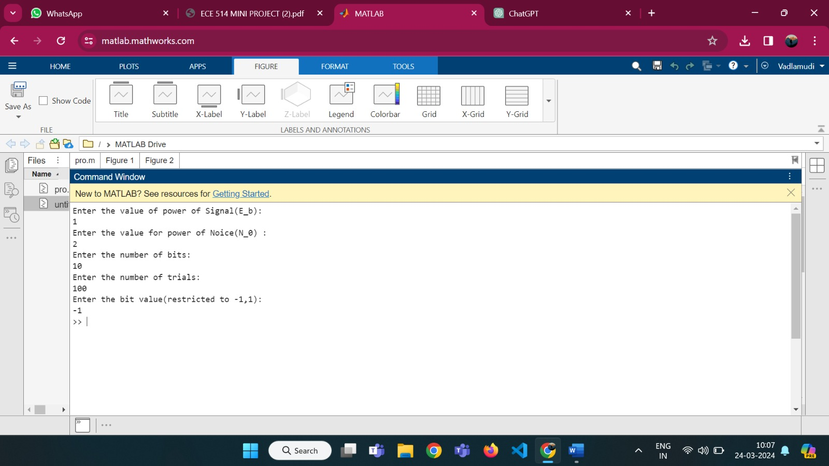

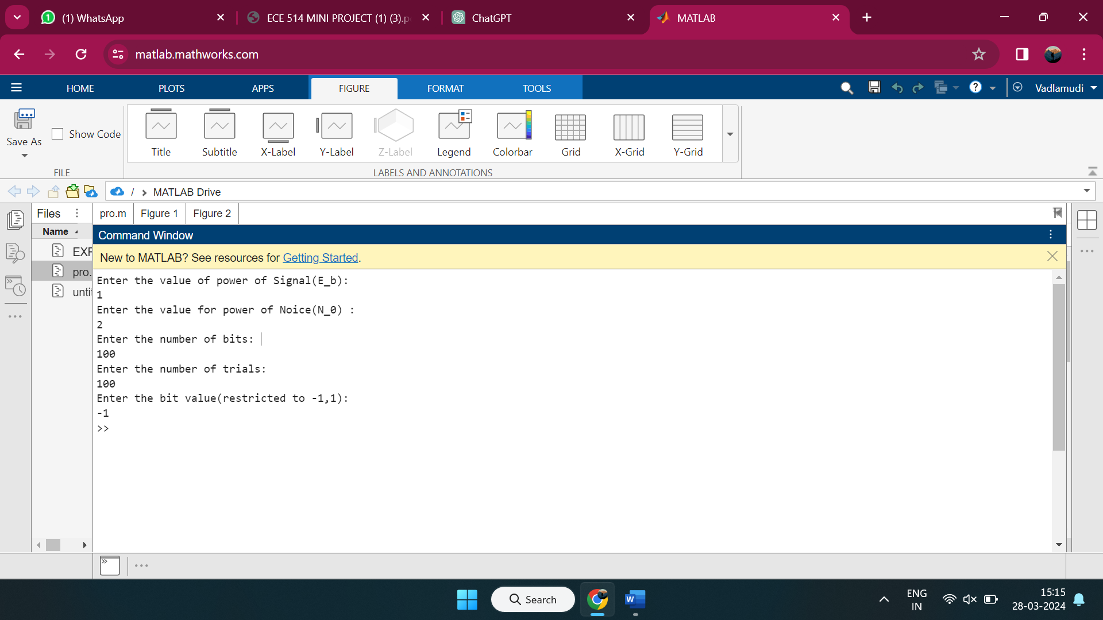

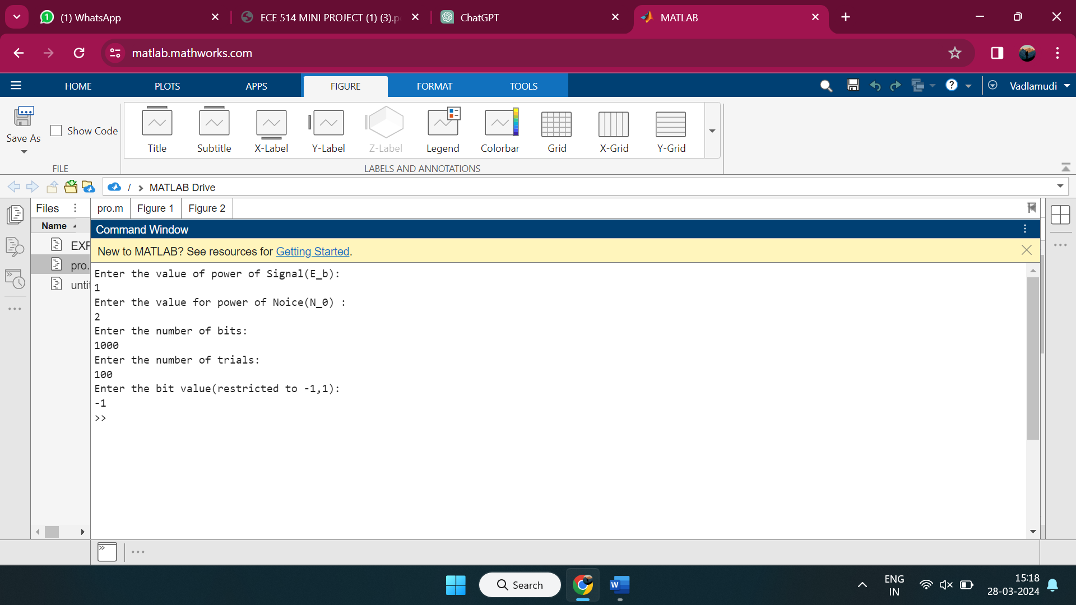

**Conclusion:**

In conclusion, the Bit Error Estimator (BER) plays a pivotal role in digital communication systems by accurately quantifying the Bit Error Rate, thereby enabling the assessment of system performance and reliability. Throughout this discourse, we have explored the various components, methodologies, and significance associated with BER estimation.

The development of BER estimation algorithms involves a systematic approach encompassing data acquisition, preprocessing, signal analysis, error detection, error correction, and the application of advanced estimation techniques. Simulation frameworks and validation procedures are utilized to evaluate algorithm performance under diverse communication scenarios, while optimization techniques aim to enhance efficiency and accuracy.

By accurately estimating the Bit Error Rate, BER estimators facilitate informed decision-making regarding system design, modulation schemes, error correction strategies, and overall communication protocol optimization. Furthermore, BER estimation contributes to the enhancement of communication system reliability, throughput, and efficiency, thereby ensuring robust data transmission in a wide range of applications.

In essence, the Bit Error Estimator serves as a critical tool for engineers, researchers, and practitioners in the field of digital communications, enabling the development of resilient and high-performance communication systems. As technology advances and communication demands evolve, ongoing research and innovation in BER estimation will continue to drive improvements in digital communication technologies, ultimately shaping the future of global connectivity.

With this project I was able to learn about the practical implementation of confidence interval in the field of Digital Communication. To determine the quality of digital communication system we measure its Bit Error Rate or probability of bit error. To find bit error we can use the mean estimator in the system and it will give us a proper result as long as we have taken a large enough sample size. The most important take away was that with larger datasets our confidence intervals grow even more certain.

**Future Scope**

The future scope of Bit Error Estimator (BER) is rich with possibilities, poised to propel digital communication systems to new heights of efficiency, reliability, and adaptability. As technology advances, there is a growing need for advanced BER estimation techniques that can keep pace with emerging communication paradigms. This entails research into innovative algorithms and methodologies, harnessing the power of signal processing, machine learning, and artificial intelligence to push the boundaries of BER estimation accuracy and adaptability. Moreover, the integration of BER estimation with emerging technologies such as 5G, Internet of Things (IoT), and quantum communication opens up exciting avenues for exploration. Cross-layer optimization strategies that seamlessly integrate BER estimation with other layers of the communication protocol stack promise to revolutionize system performance and efficiency. Furthermore, the quest for real-time BER monitoring systems and energy-efficient BER estimation techniques will drive innovation in network management and device design, ensuring robust and sustainable communication networks. Collaboration between researchers, industry stakeholders, and standards organizations will be crucial in shaping the future of BER estimation, fostering standardization, and facilitating widespread adoption in commercial communication products and standards. In essence, the future of BER estimation is marked by continuous innovation, collaboration, and adaptation, poised to meet the evolving demands of digital communication in an increasingly interconnected world.

**REFERENCES:**

1. <https://en.wikipedia.org/wiki/Bit_error_rate>
2. Probability and Random Processes for Electrical and Computer Engineers – John A. Gubner